Capstone Project Report

## **Project Title:** CSS Theme Implementation and Data Migration

## **Contributor:** Krishna Pandya

### **Summary**

### As the team leader and lead developer, I had a major role in the front-end design and back-end functioning of the Trade Vista e-commerce platform. The platform's success largely depended on my leadership in deciding on and implementing the site's style and controlling team dynamics during pivotal project phases.

**Key Contributions**

1. **Theme Integration Across Platforms:** Tailwind CSS Integration: I selected Tailwind CSS for the site's theme to guarantee a contemporary and uniform design throughout all pages. The site's responsiveness and visual appeal were much improved by the smooth integration of this framework, which was made possible by my knowledge of front-end technology.
2. **Front page and throughout the website styling:** Maintained the homepage's visual layout and user interaction while spearheading its design and development. My stylistic strategy established the overall vibe of the website, resulting in a friendly and user-friendly interface.
3. **Contact and About Us Pages:** These crucial pages were created to improve site transparency, give users quick access to contact details, and give them information about the Trade Vista team and their objectives.
4. **Category and Brands Management - Backend Development and Team Leadership:** I put in place CRUD operations in the admin section to handle brands and categories, which are essential for inventory control and product organization. My efforts enabled me to dynamically manage and upgrade these components, which immediately aided in the platform's scalability.
5. **Support and Cooperation:** As team captain, I gave my colleagues unwavering support and direction, particularly when they faced challenging backend development problems. Drishya and I collaborated closely to guarantee the smooth integration and operation of the admin pages' product management section.

#### **Challenges and Solutions**

**Theme Integration Across Platforms:** Implementing a Consistent Design: Upholding responsiveness and a consistent design language across all platforms was one of the main obstacles. To solve this, I painstakingly tailored Tailwind CSS presets to Trade Vista's particular requirements.

### **Data Management in Admin Pages:** I had trouble smoothly integrating CRUD operations for the new categories and brand pages. By improving the backend APIs and making sure there was strong data validation and error handling, I was able to overcome these difficulties.

### **Future Plans**

**Ongoing UI/UX Improvements:** To stay up to date with contemporary trends and user expectations, it is advised that the website's design be evaluated and modified regularly. Regular UI/UX audits could be advantageous.

**Admin Pages' Advanced Features:** Adding more statistics and finer-grained content control to the admin pages could make administrative jobs even easier and offer deeper insights into how the organization is run.

GitHub Link : <https://github.com/kp-46>

Website Link : https://capestone-deploy.vercel.app/

### **Pictures**

**Home Page**

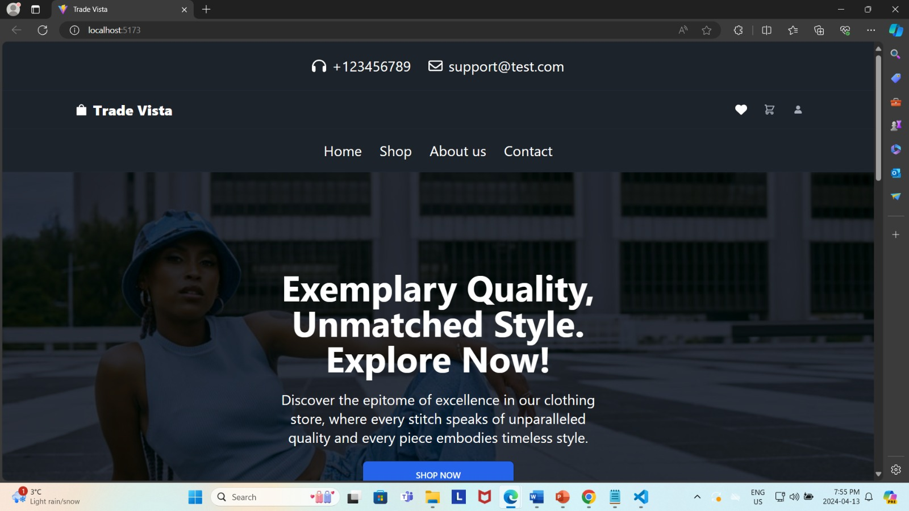

**Products Page**

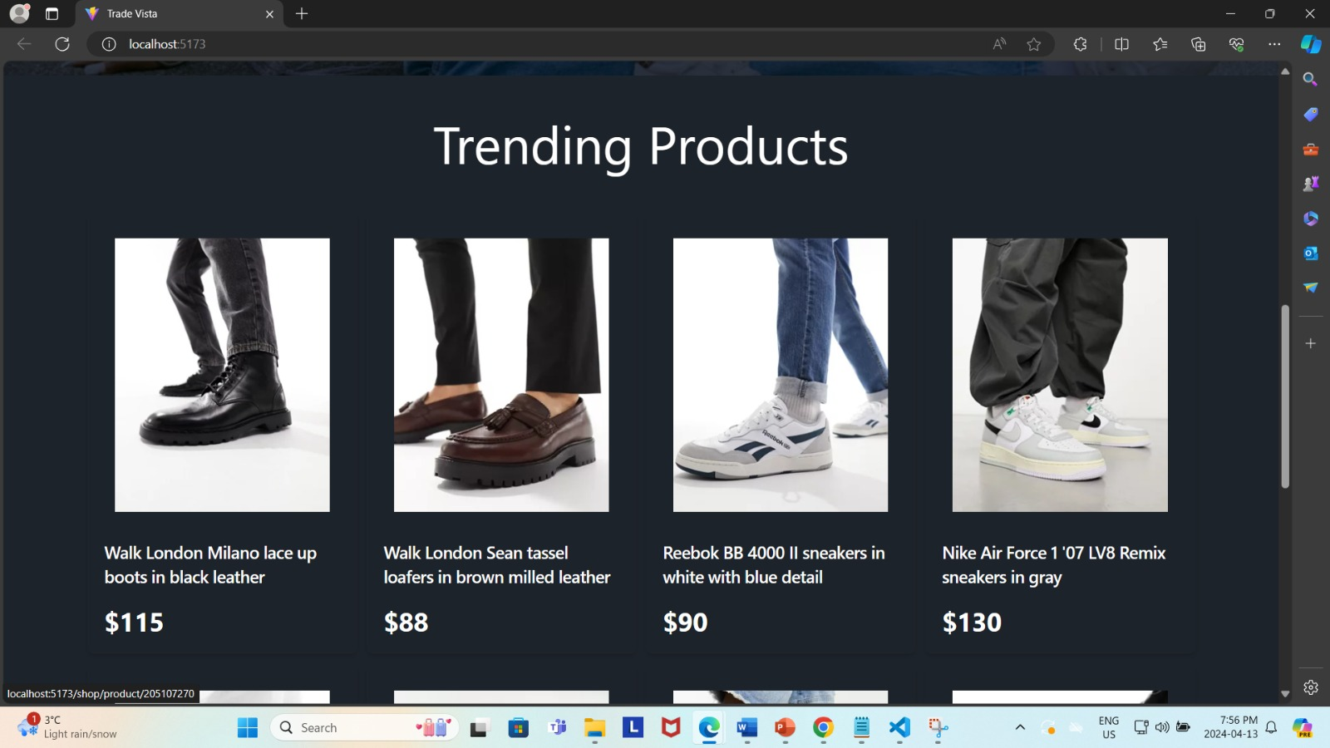

**Cart Page/ Payment**

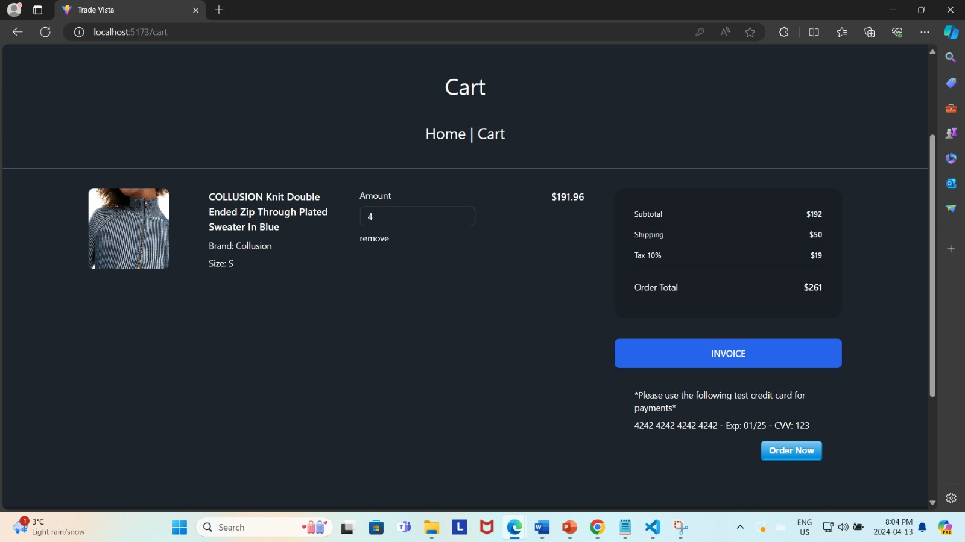

**Invoice(Printing)**

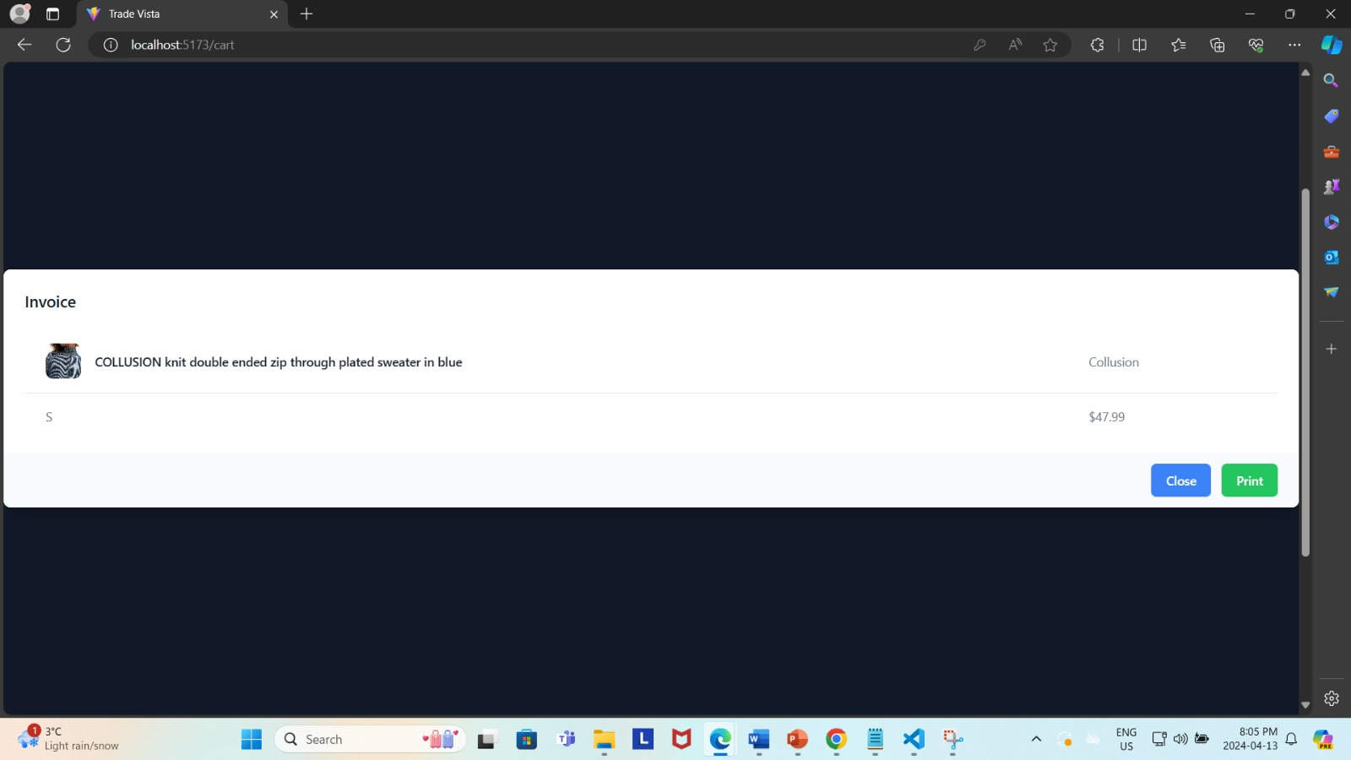

**Invoice(PDF)**

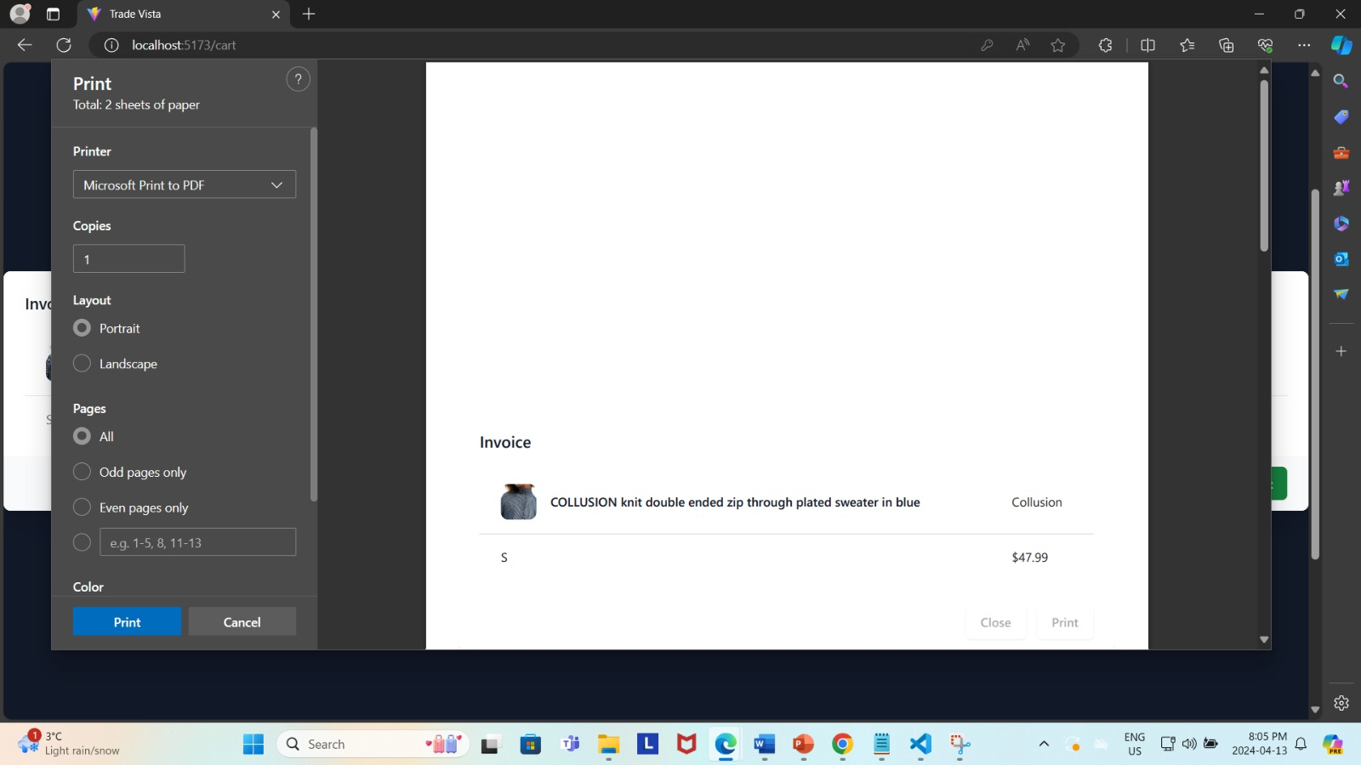

**Categories**

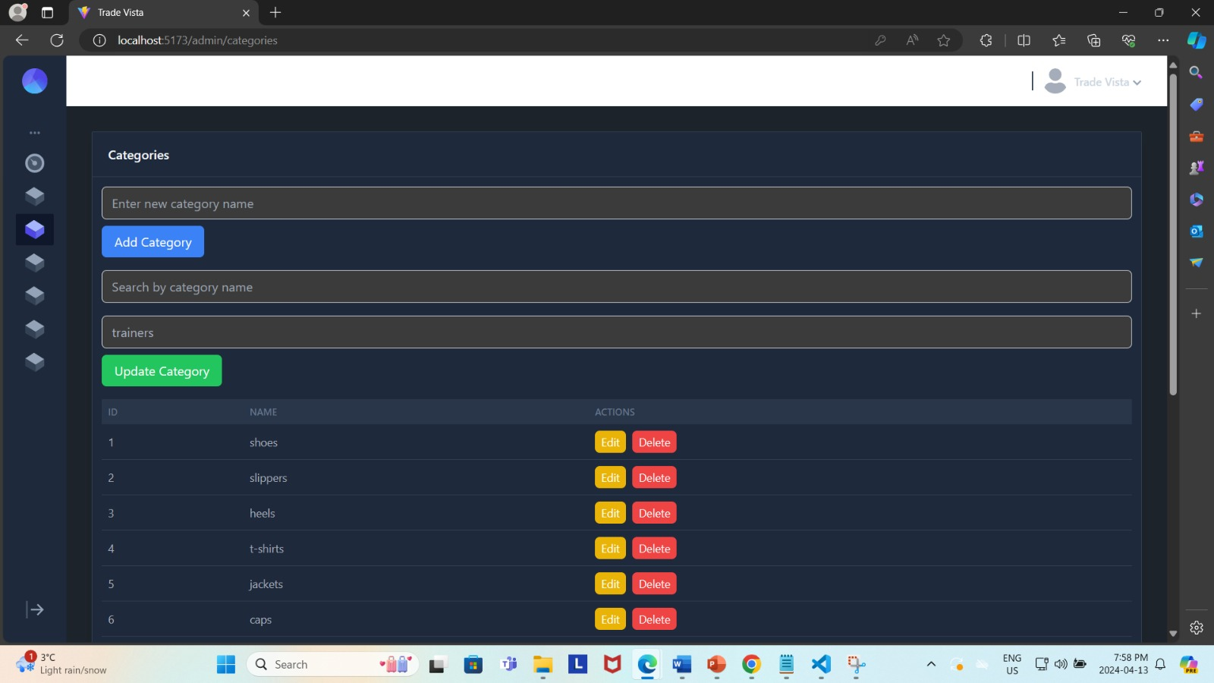

**Add Categories**

**Category Added**

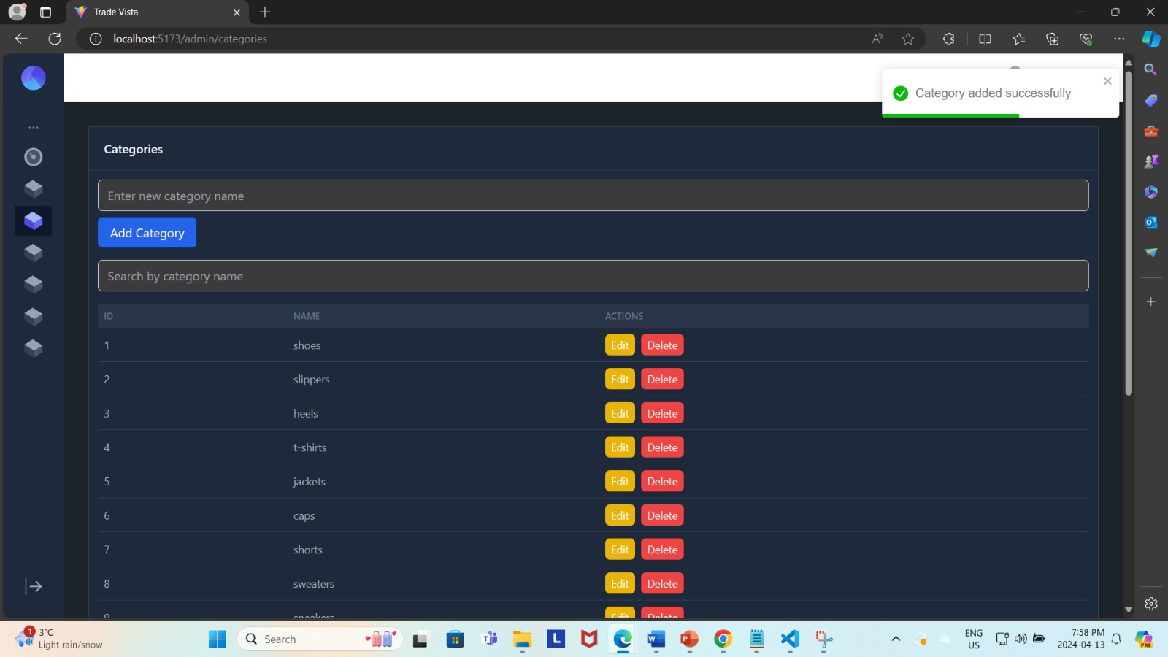

**New Category Added**

**Category Deleted**

